Run 13 - Voltage Sweep: -20 kV, 2mA, 800K particles, Deuterium

Central Anode Height
Cathode voltage | -20000.0 V (-20 kV)
Central potential (avg of x/y/z probes) | -18627.20 V
Central potential (x axis) | -18627.20 V
Central potential (y axis) | -18627.20 V
Central potential (z axis) | -18627.20 V
Central anode height | 6.864 % of |V_cathode|
Height % = (|V_cathode| - |V_centre|) / |V_cathode|. Positive value = central potential is LESS negative than the cathode (space-charge / geometric 'virtual anode' lift).

Radial Potential Profiles
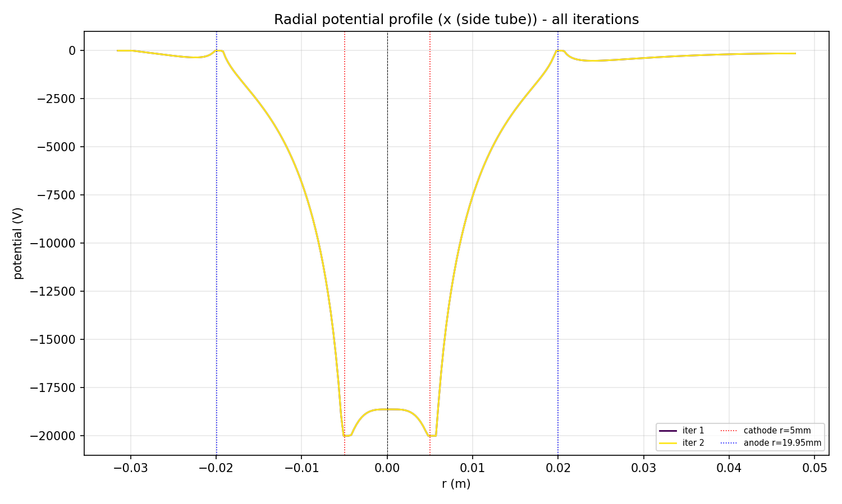
Radial potential along x (side tube), all iterations overlaid
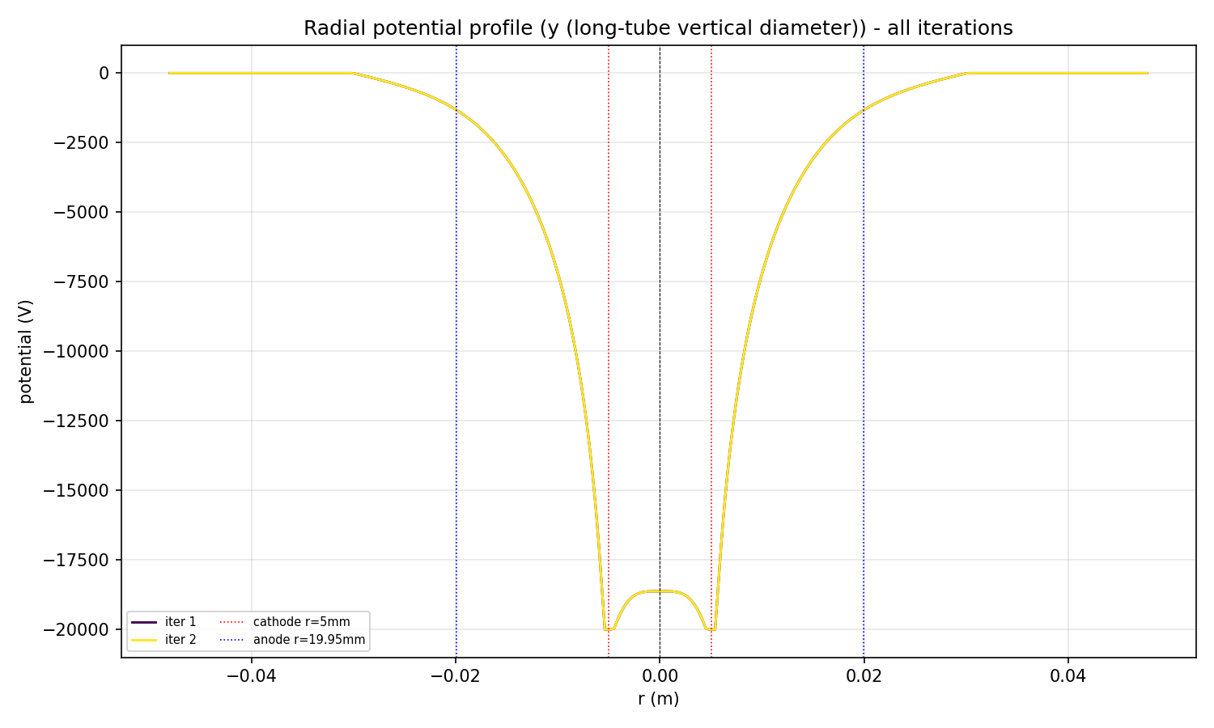
Radial potential along y (long-tube vertical diameter), all iterations overlaid
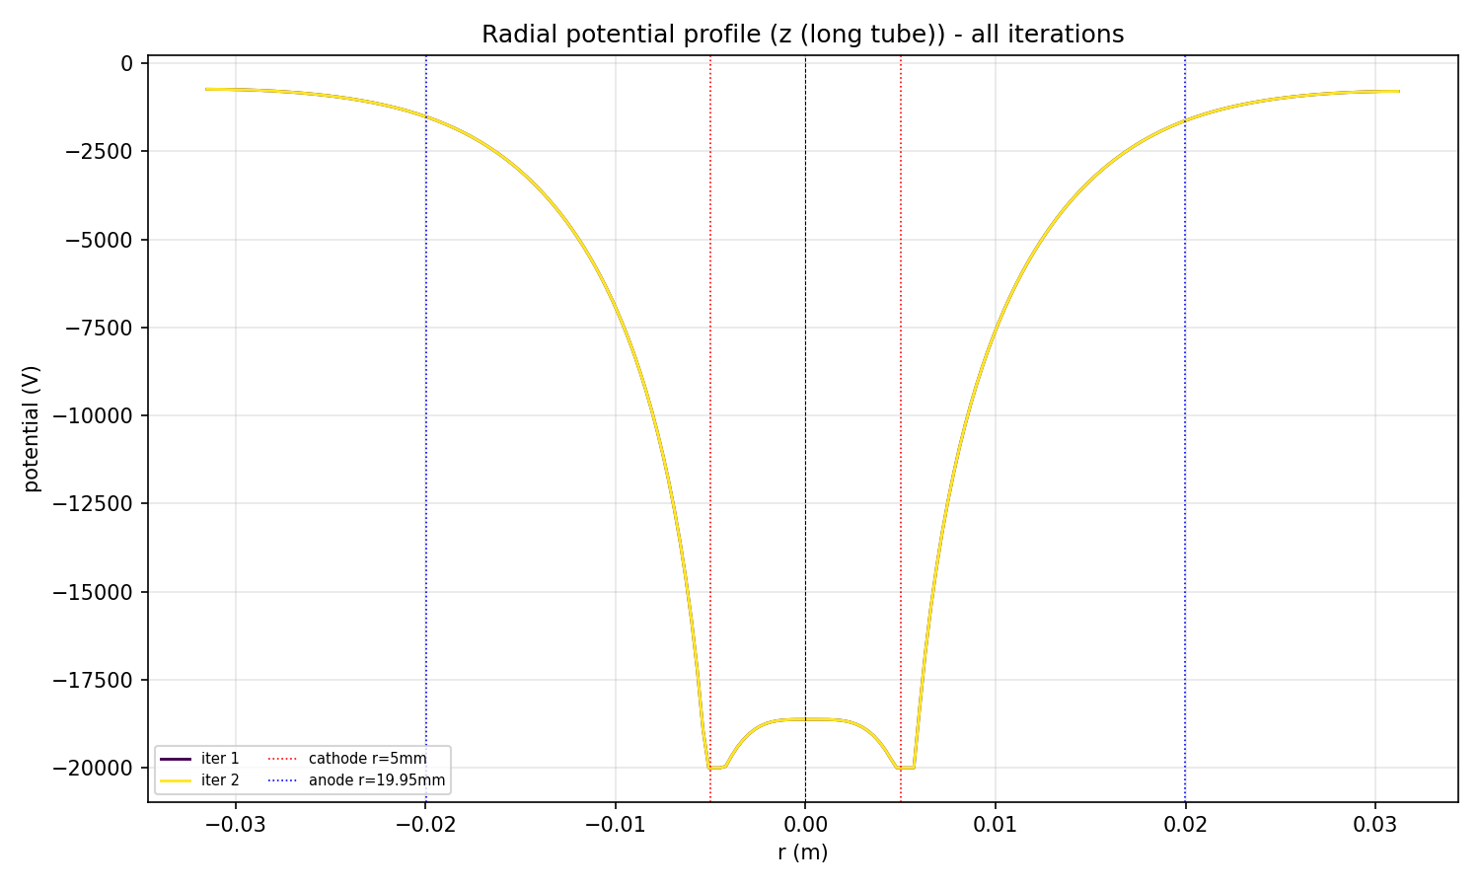
Radial potential along z (long tube), all iterations overlaid

Final Potential Field
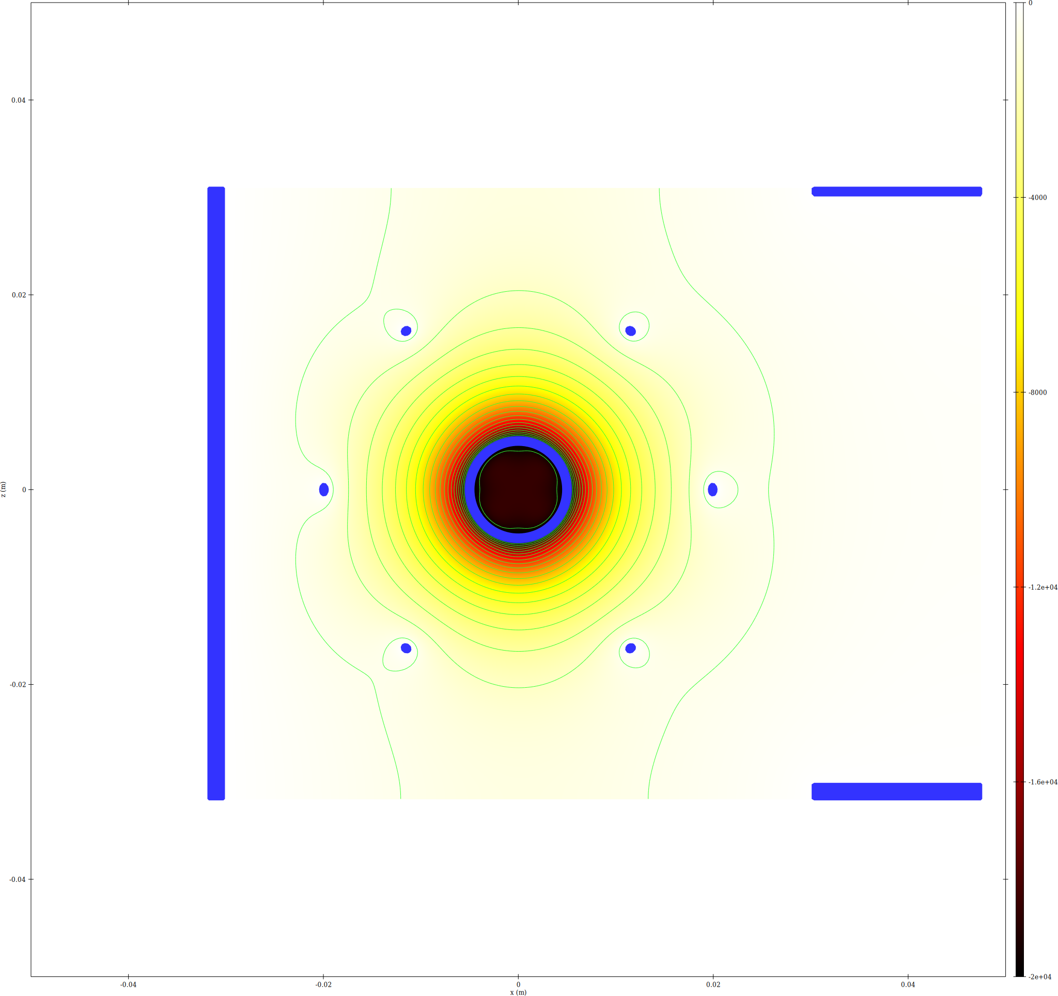
epot XZ slice
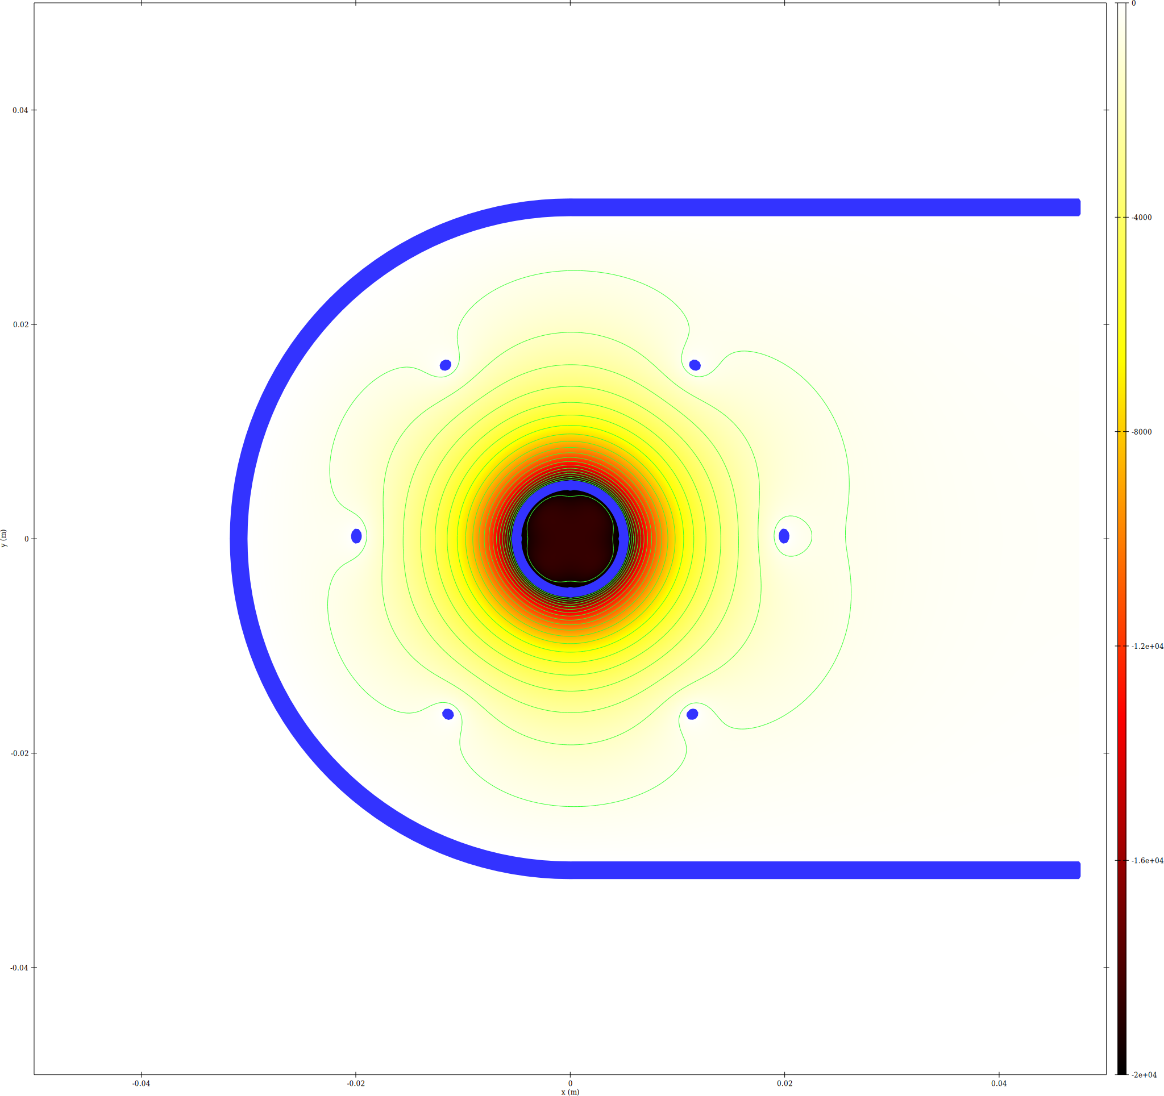
epot XY slice
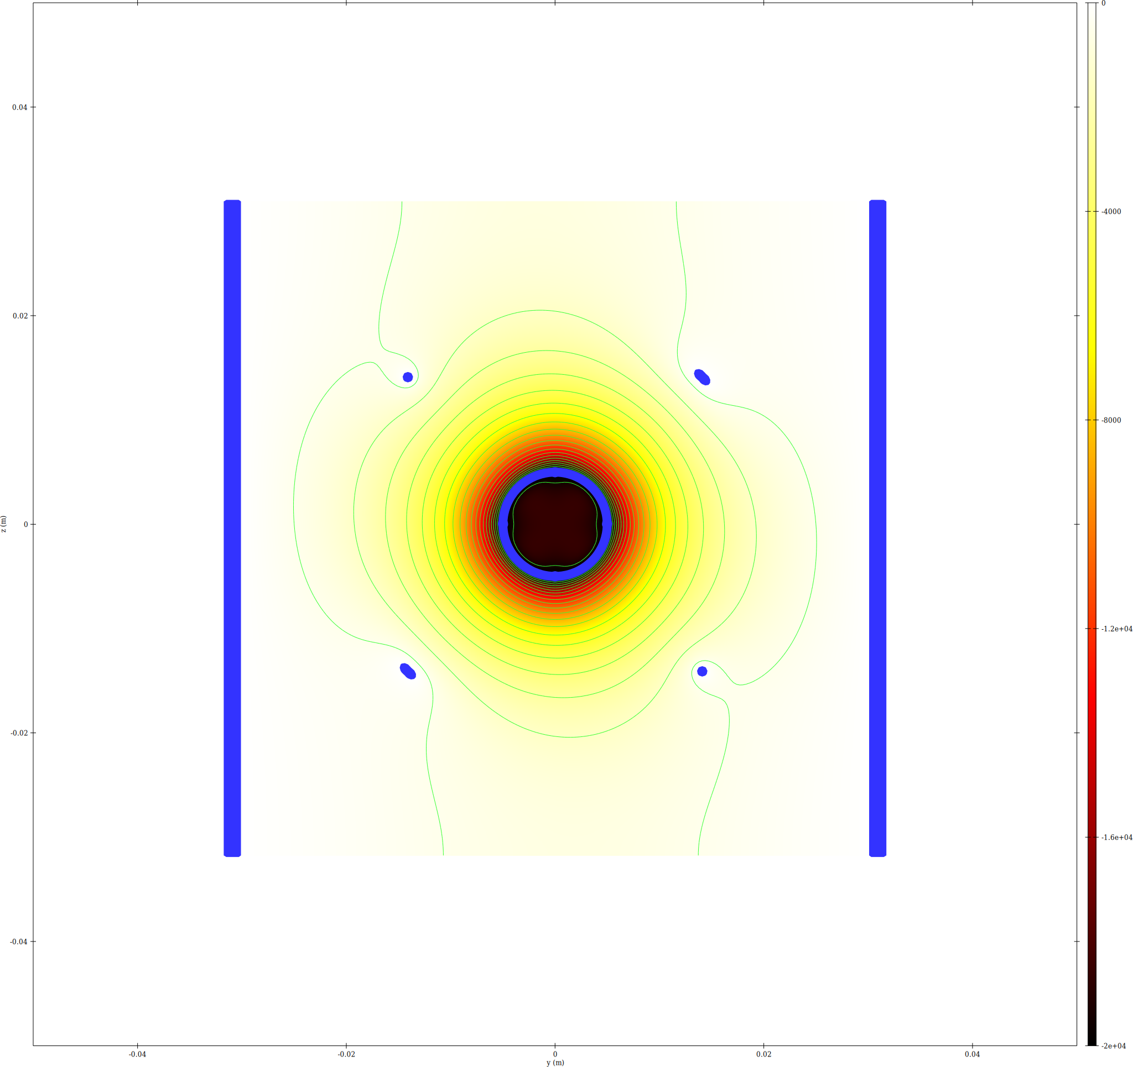
epot YZ slice at x=0

Trajectory Density
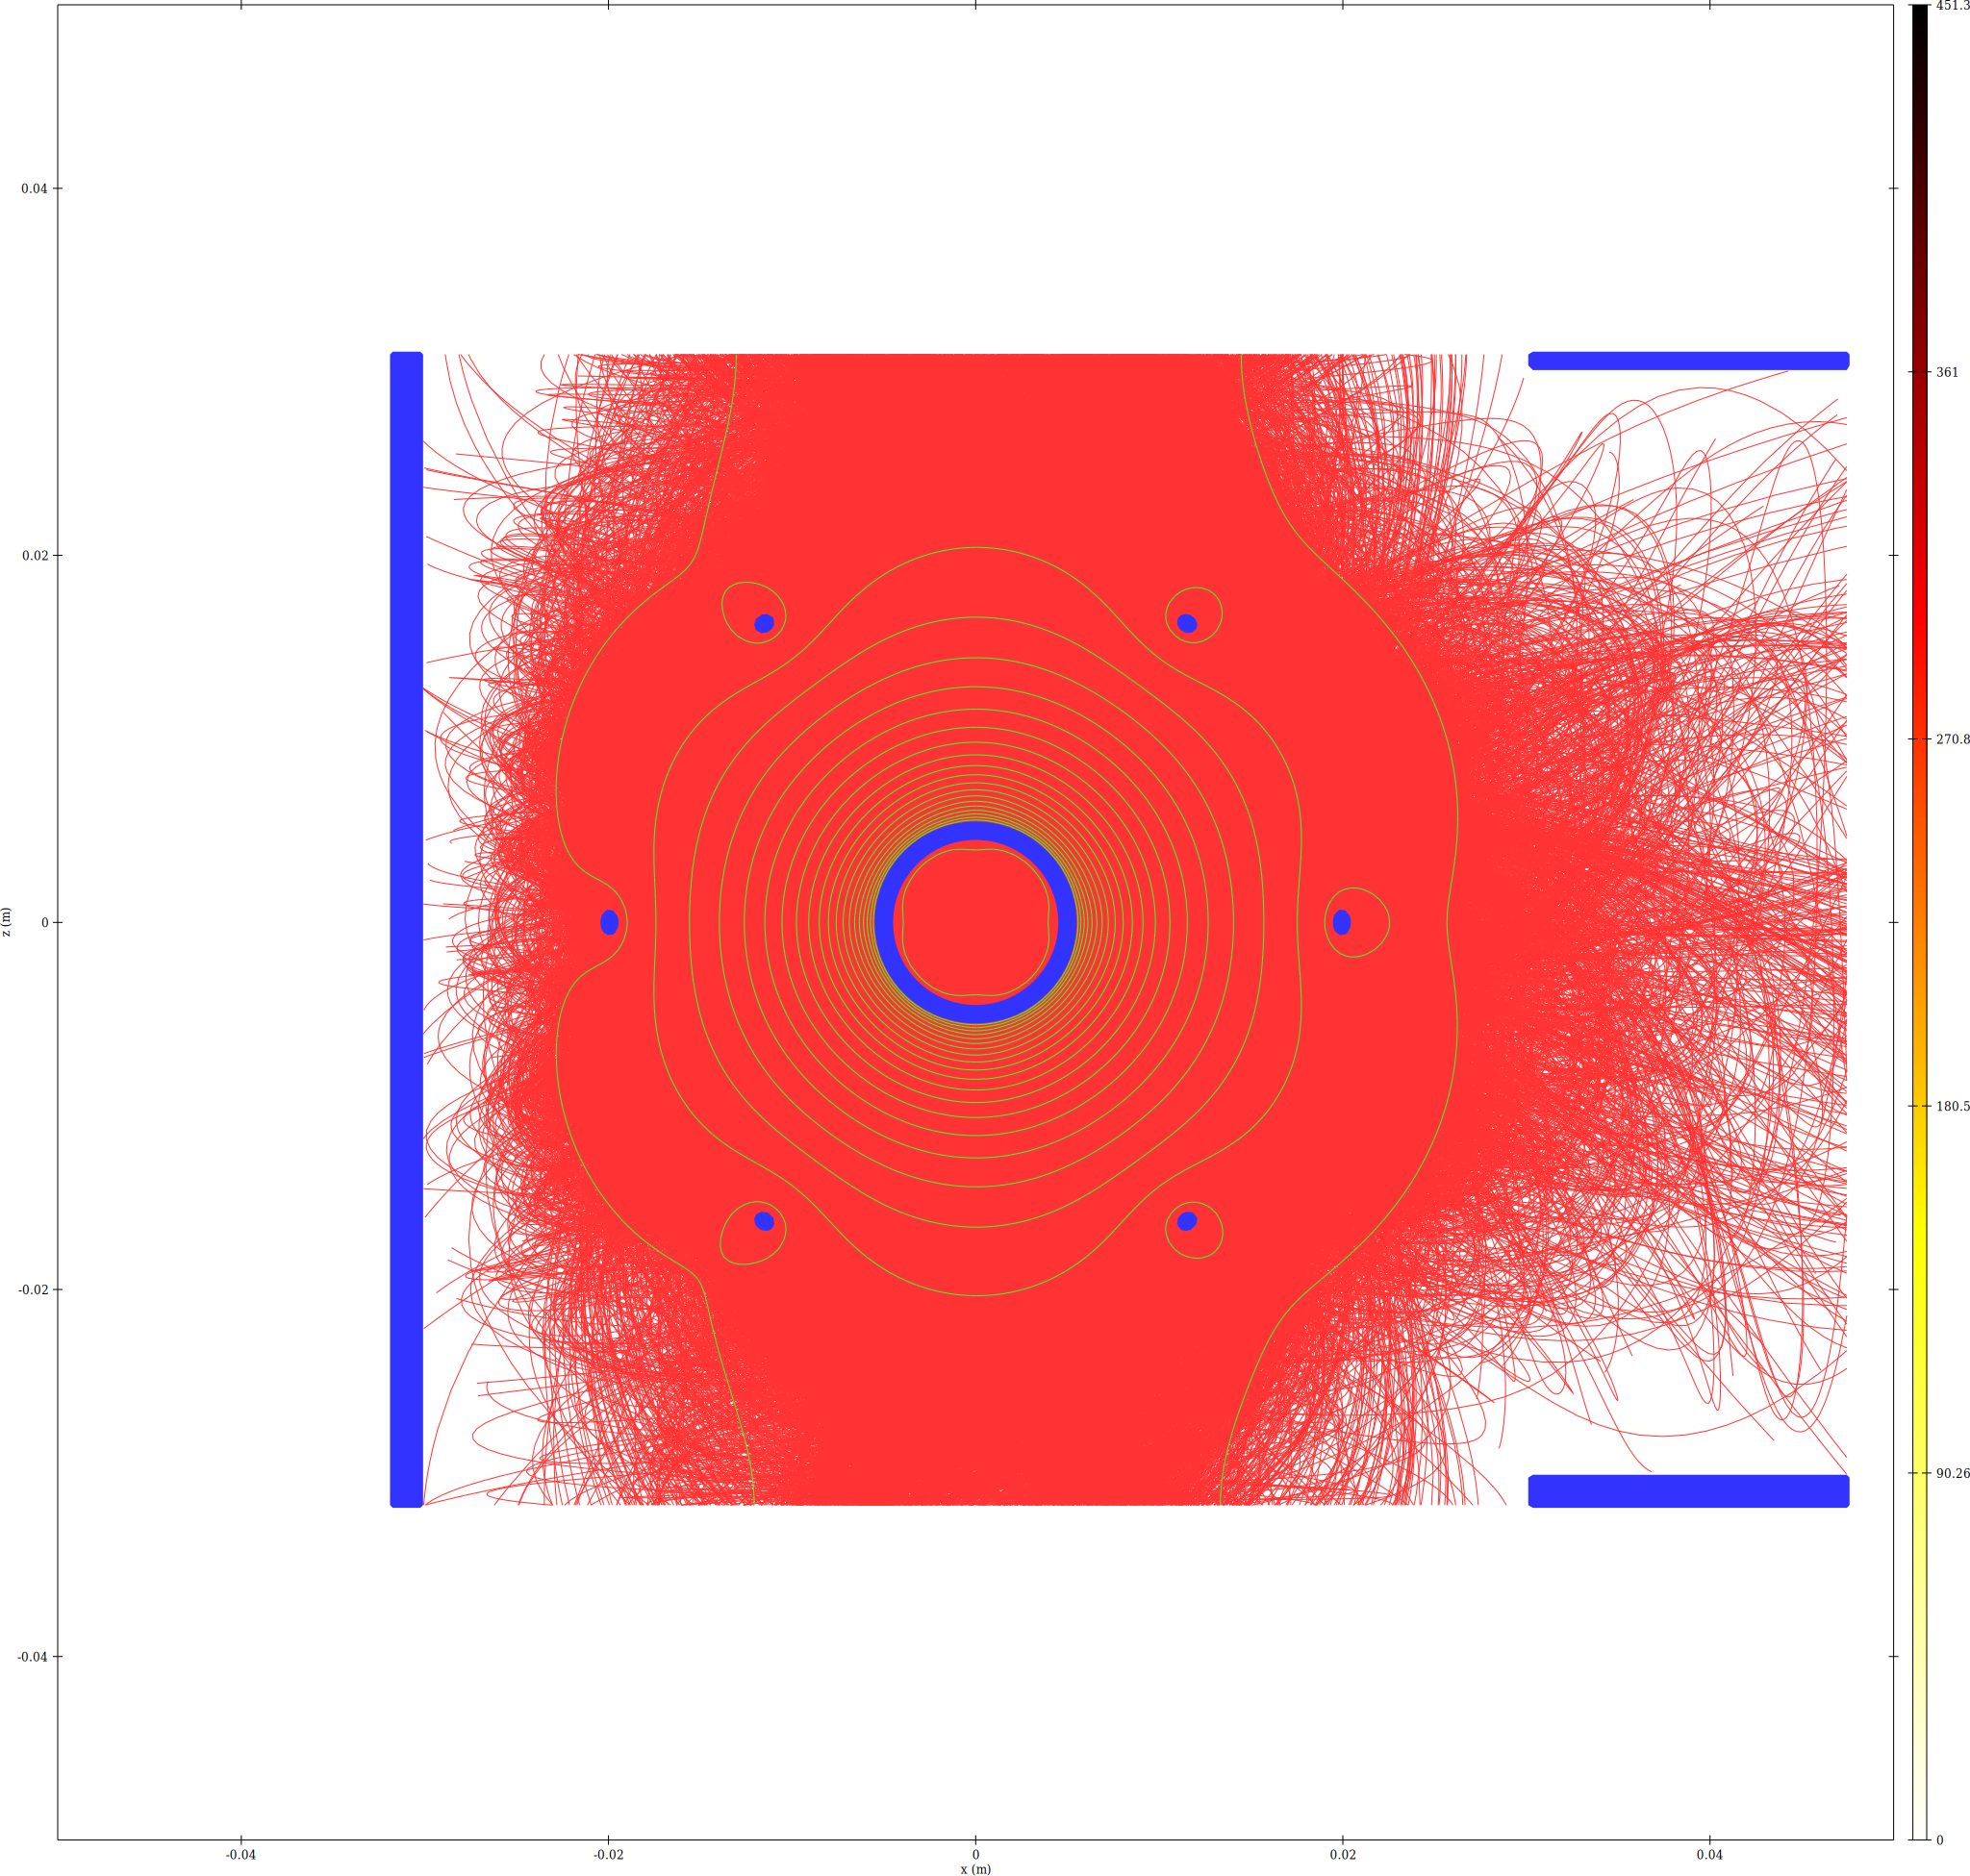
Trajectory density XZ slice
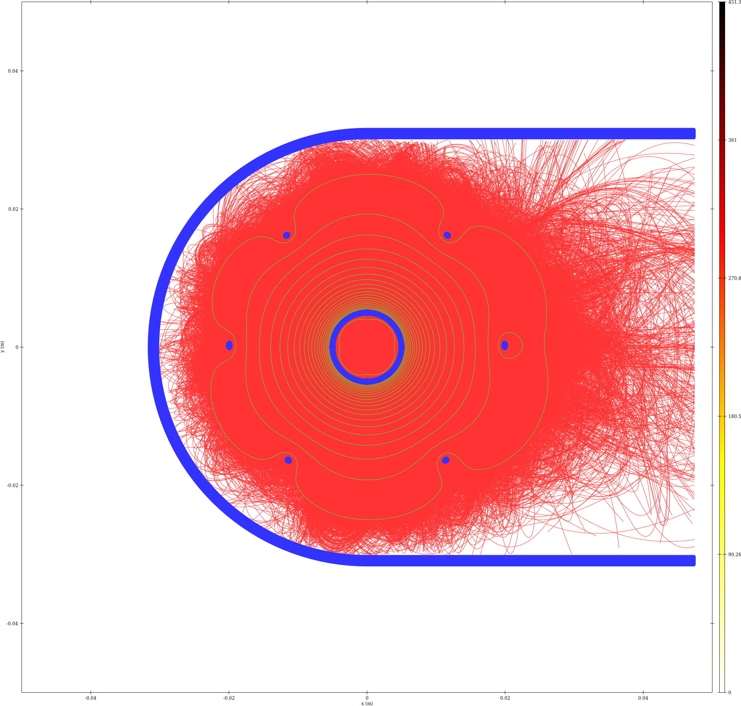
Trajectory density XY slice

Memory Estimate
Memory breakdown for run13/
N_clouds (ions) = 800000
N_clouds_e (electrons) = 800000
bytes/particle = 108, bytes/step = 56
Mesh nodes = 17808000 (4 scalar + 1 vector(3) fields)
Mesh-field memory = 0.929 GB
Solver workspace est. = 1.858 GB
Geometry est. = 0.066 GB
Constant overhead total = 2.853 GB
Particle data (constant) = 0.161 GB
iteration | ion_steps | e_steps | traj_MB | overhead_MB | total_GB
1 | 67076422 | 31586798 | 5269.18 | 3085.88 | 8.1592
2 | 67009202 | 31588628 | 5265.69 | 3085.88 | 8.1558

Convergence
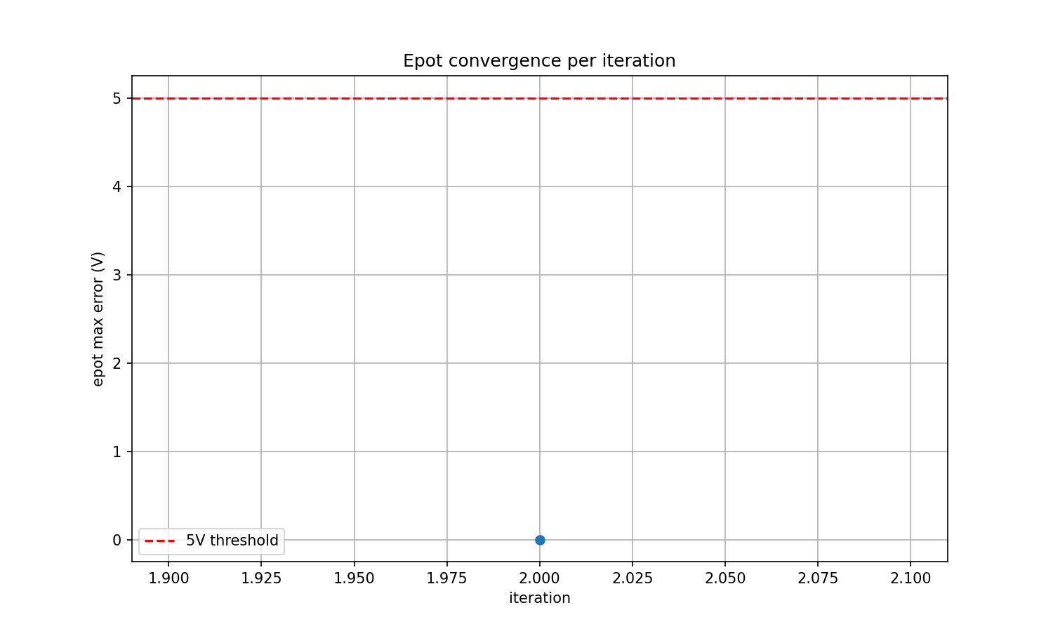
Epot max error vs iteration

